Muhammad Ahmad

21L-5617 BS(DS)7A

Question2

1: No, ICMP messages are not sent over UDP or TCP; they are sent directly over IP.

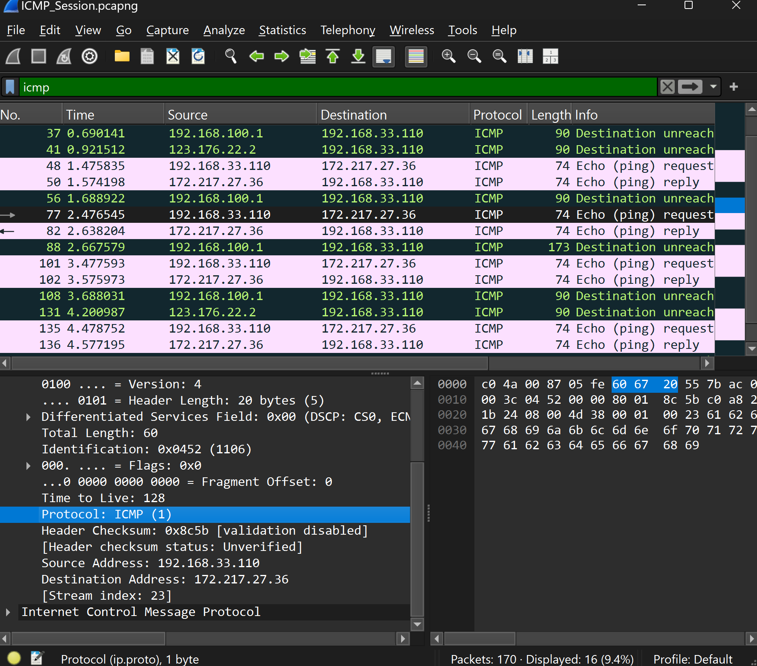

2 :

• The **link-layer (Ethernet)** address of the source host is **60:67:20:55:7b**

.

• The **link-layer (Ethernet)** address of the destination host is **c0:4a:00:87:05**

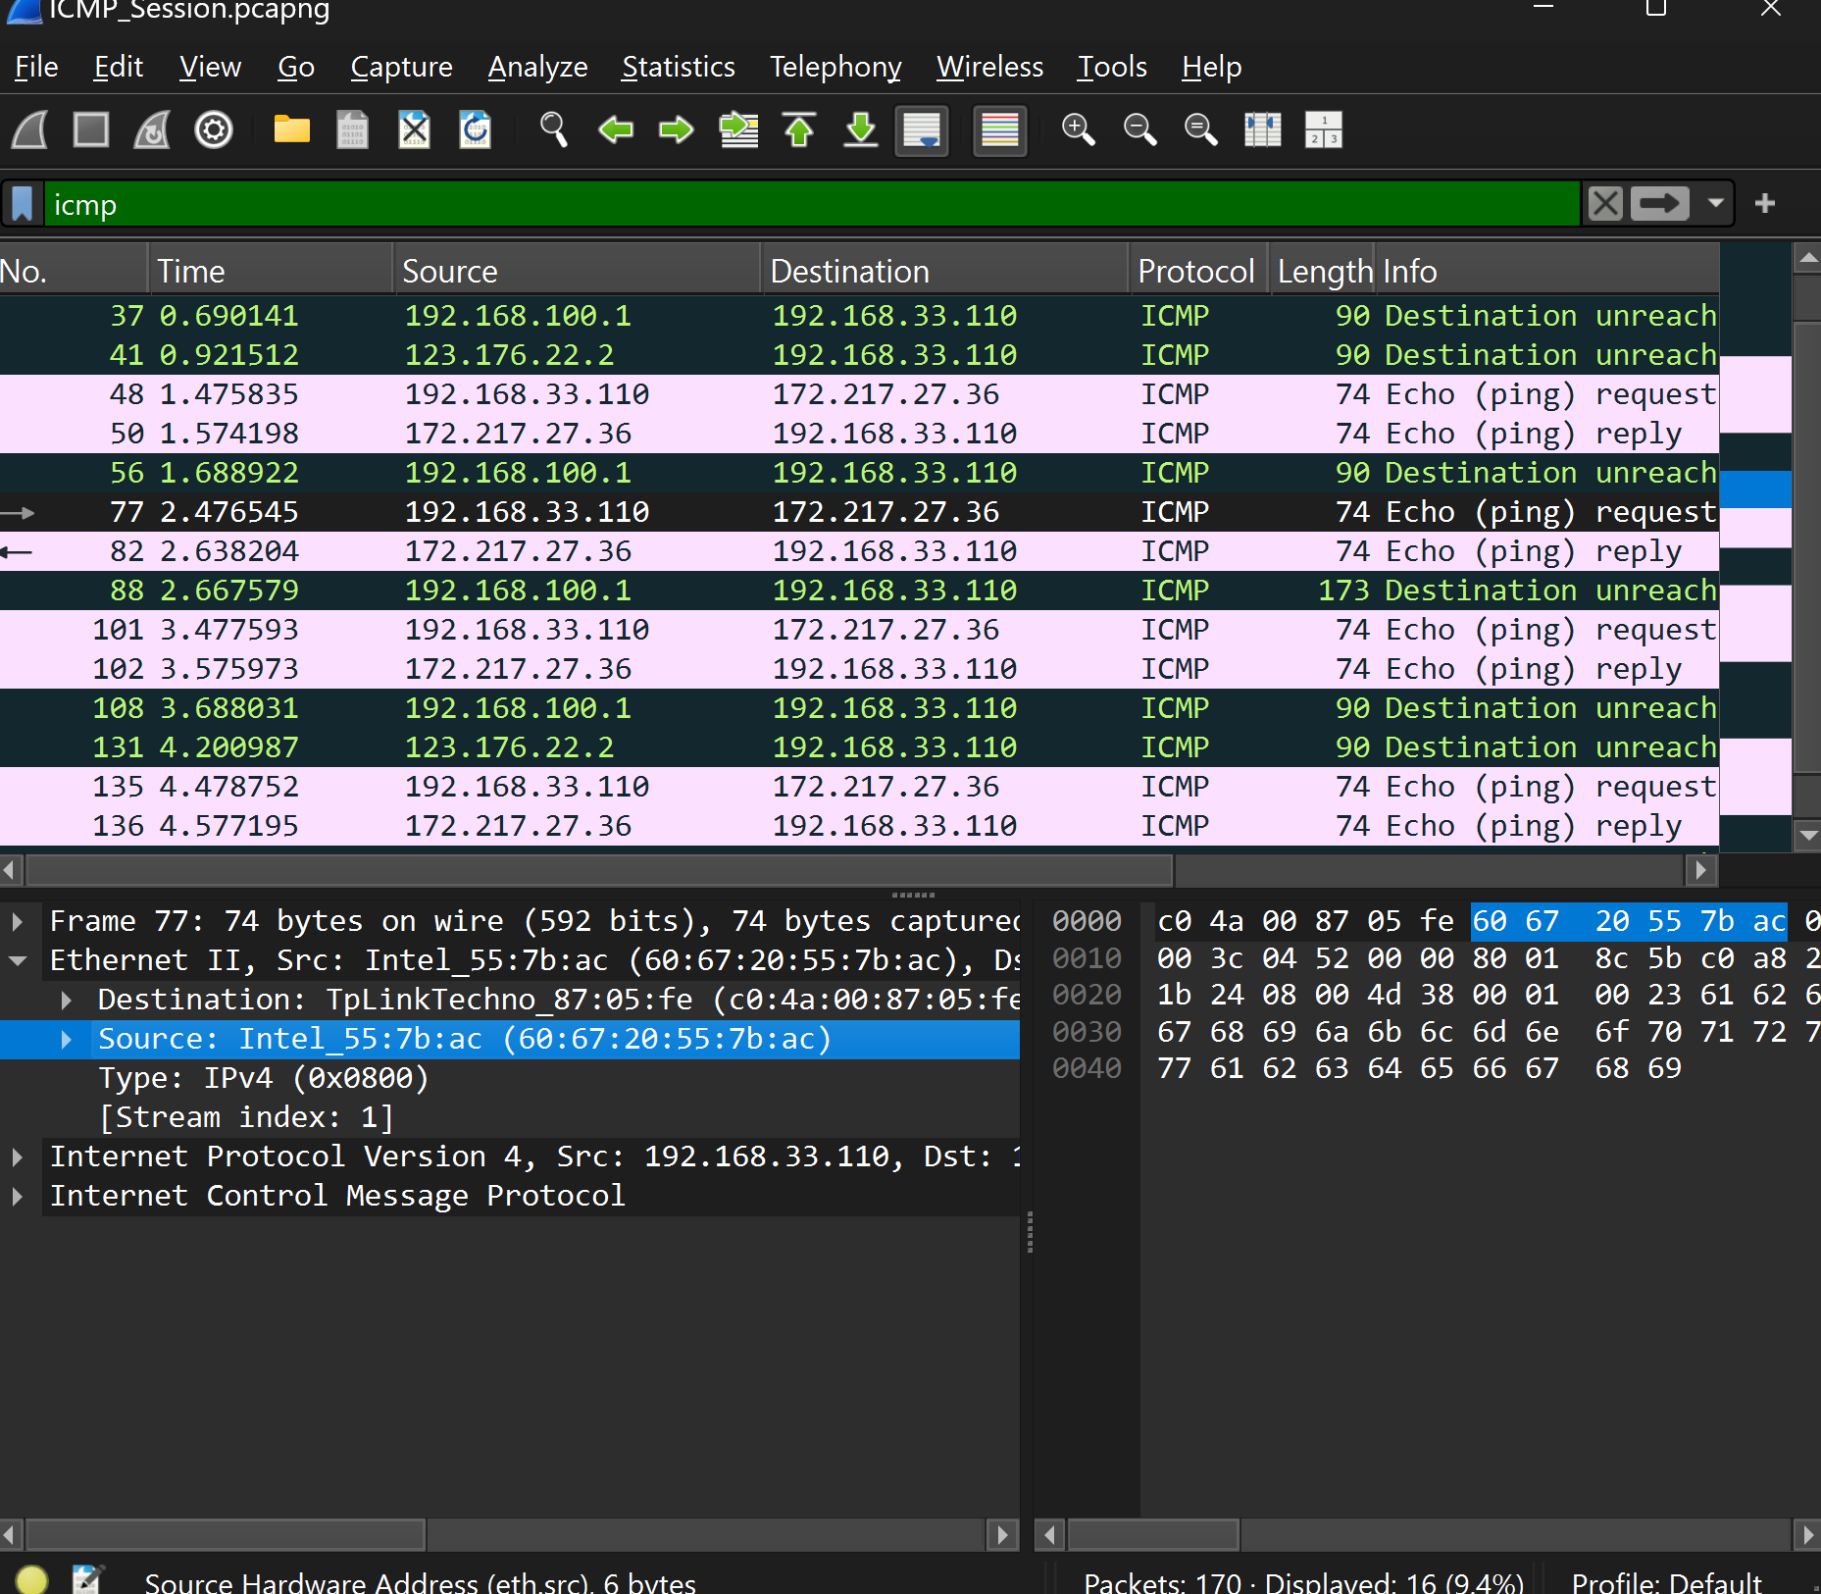

3:

Type: 8 (Echo (ping) request)

Type: 3 (Destination unreachable)

Type: 0 (Echo (ping) reply)

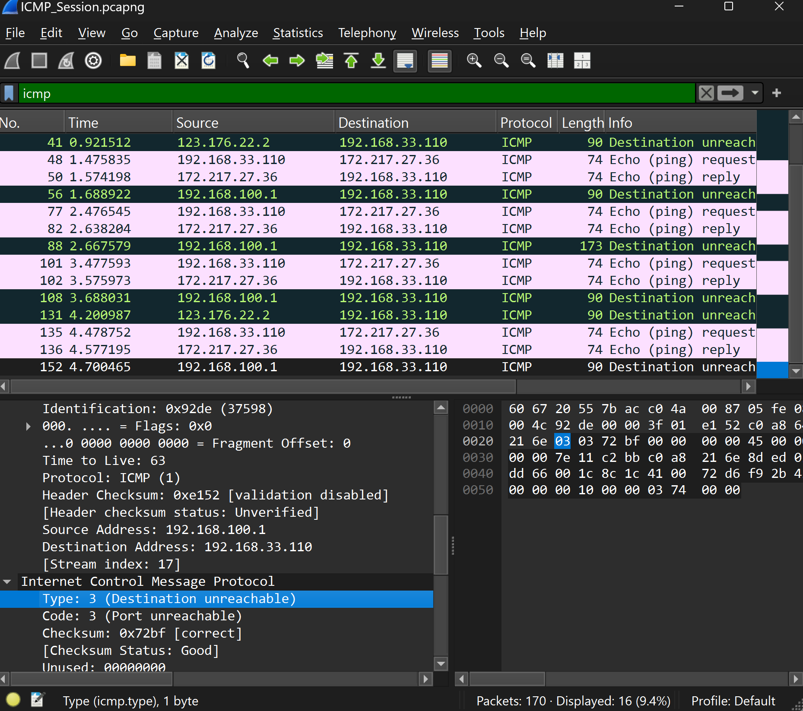

4:

**Total ICMP Requests Sent: 4 Echo Requests**

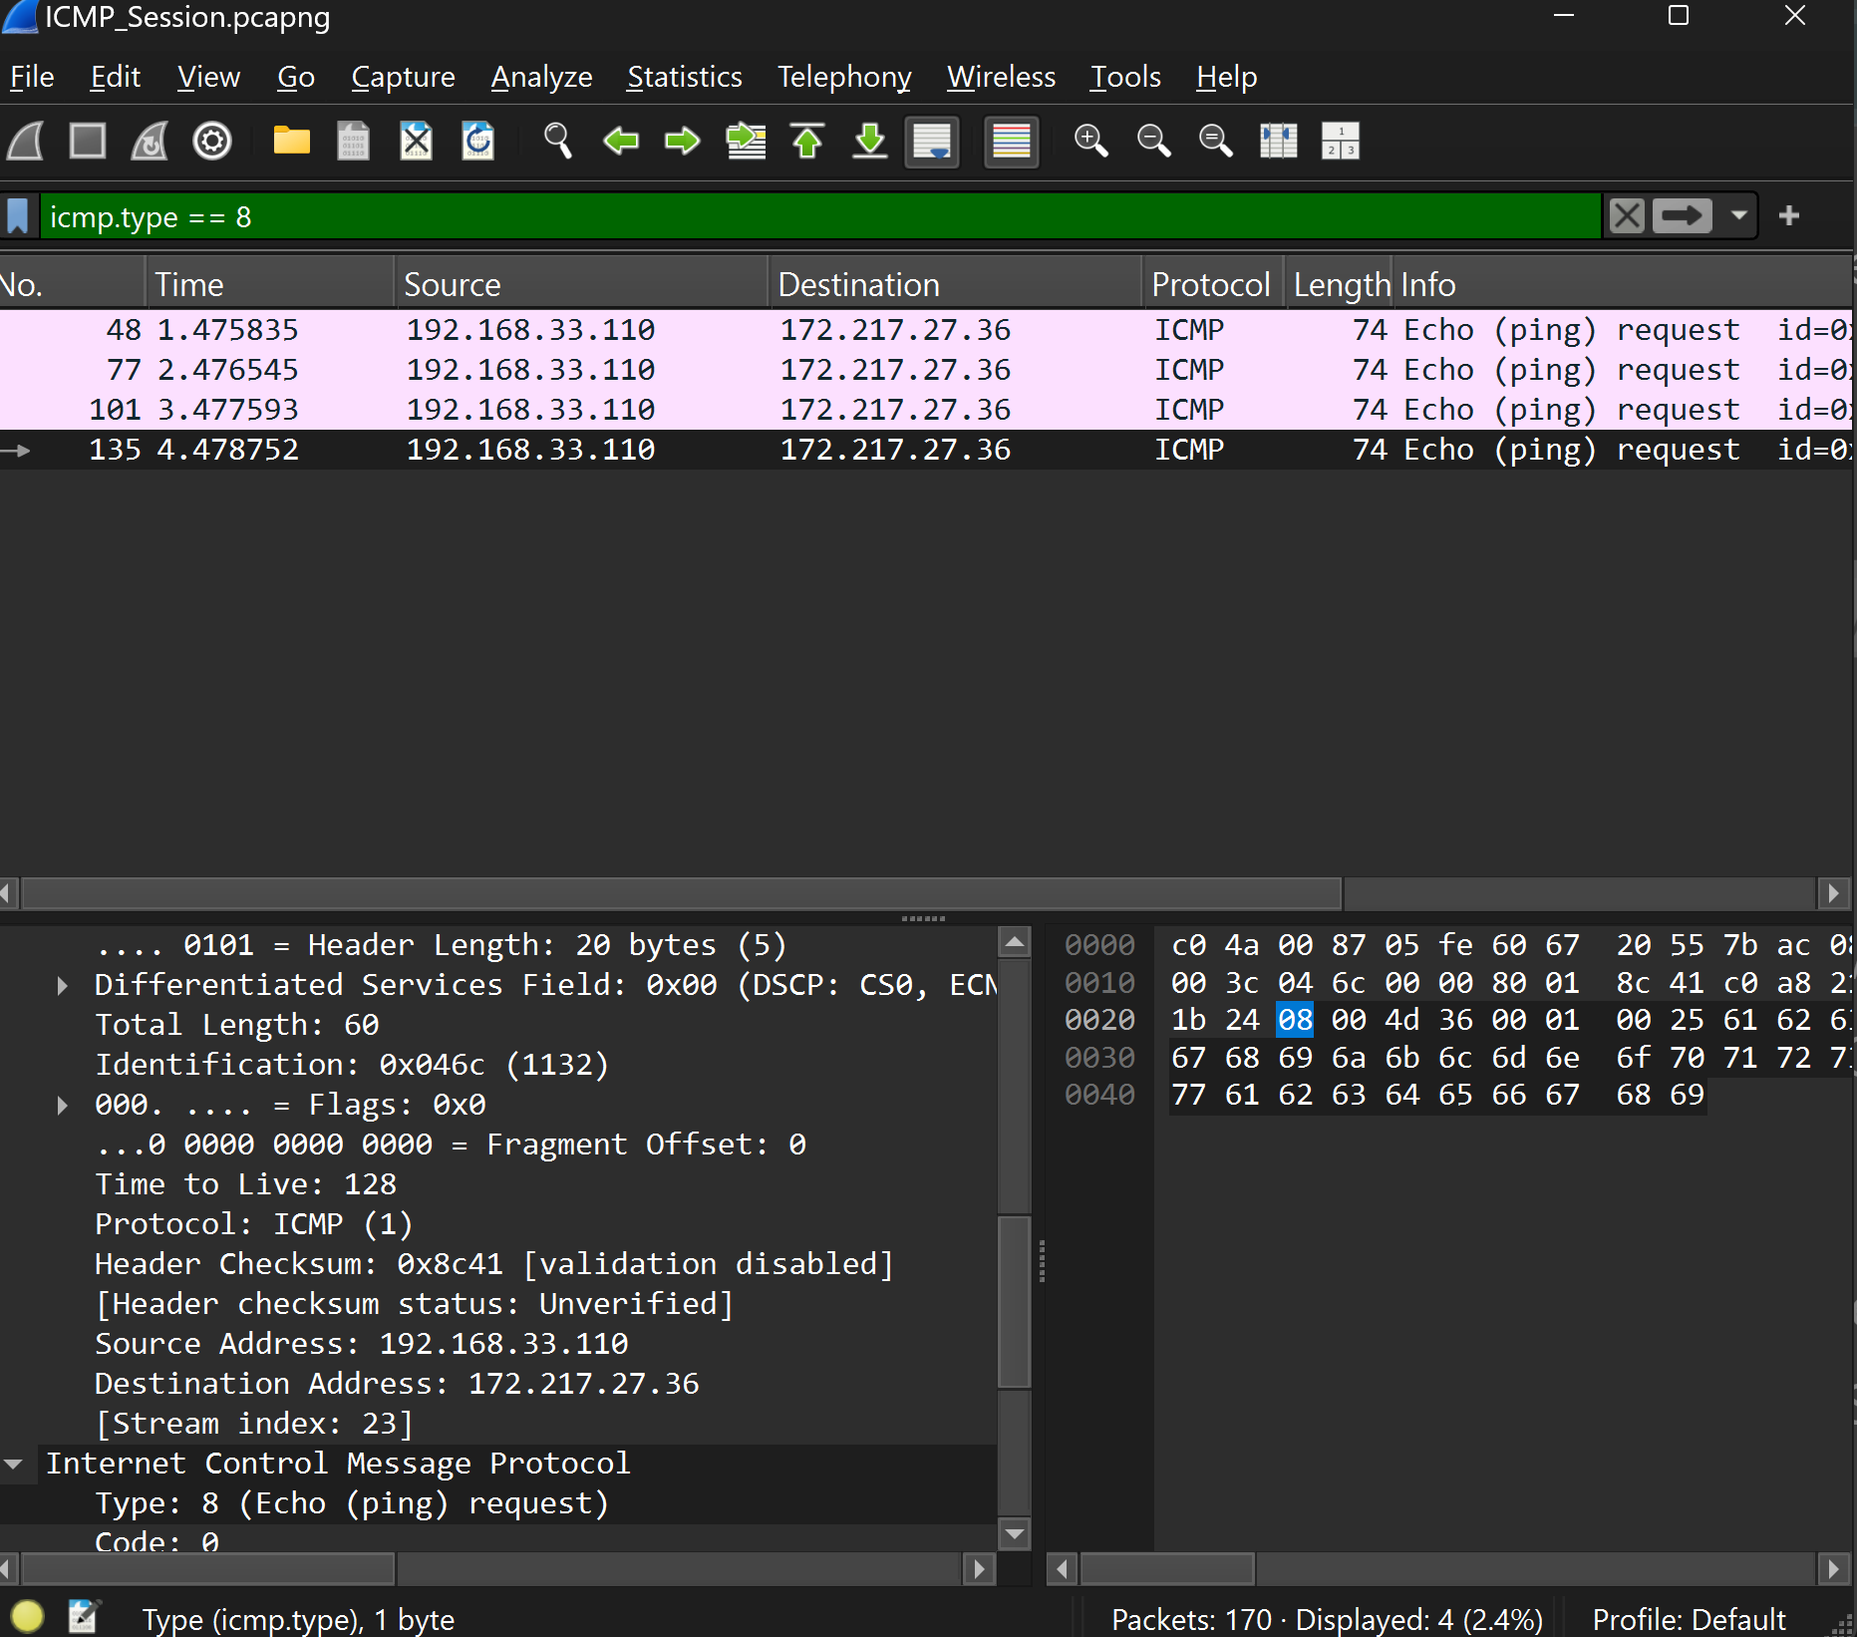

5:

• My laptop Host IP Address: 192.168.33.110

• Destination Host IP Address: 172.217.27.36

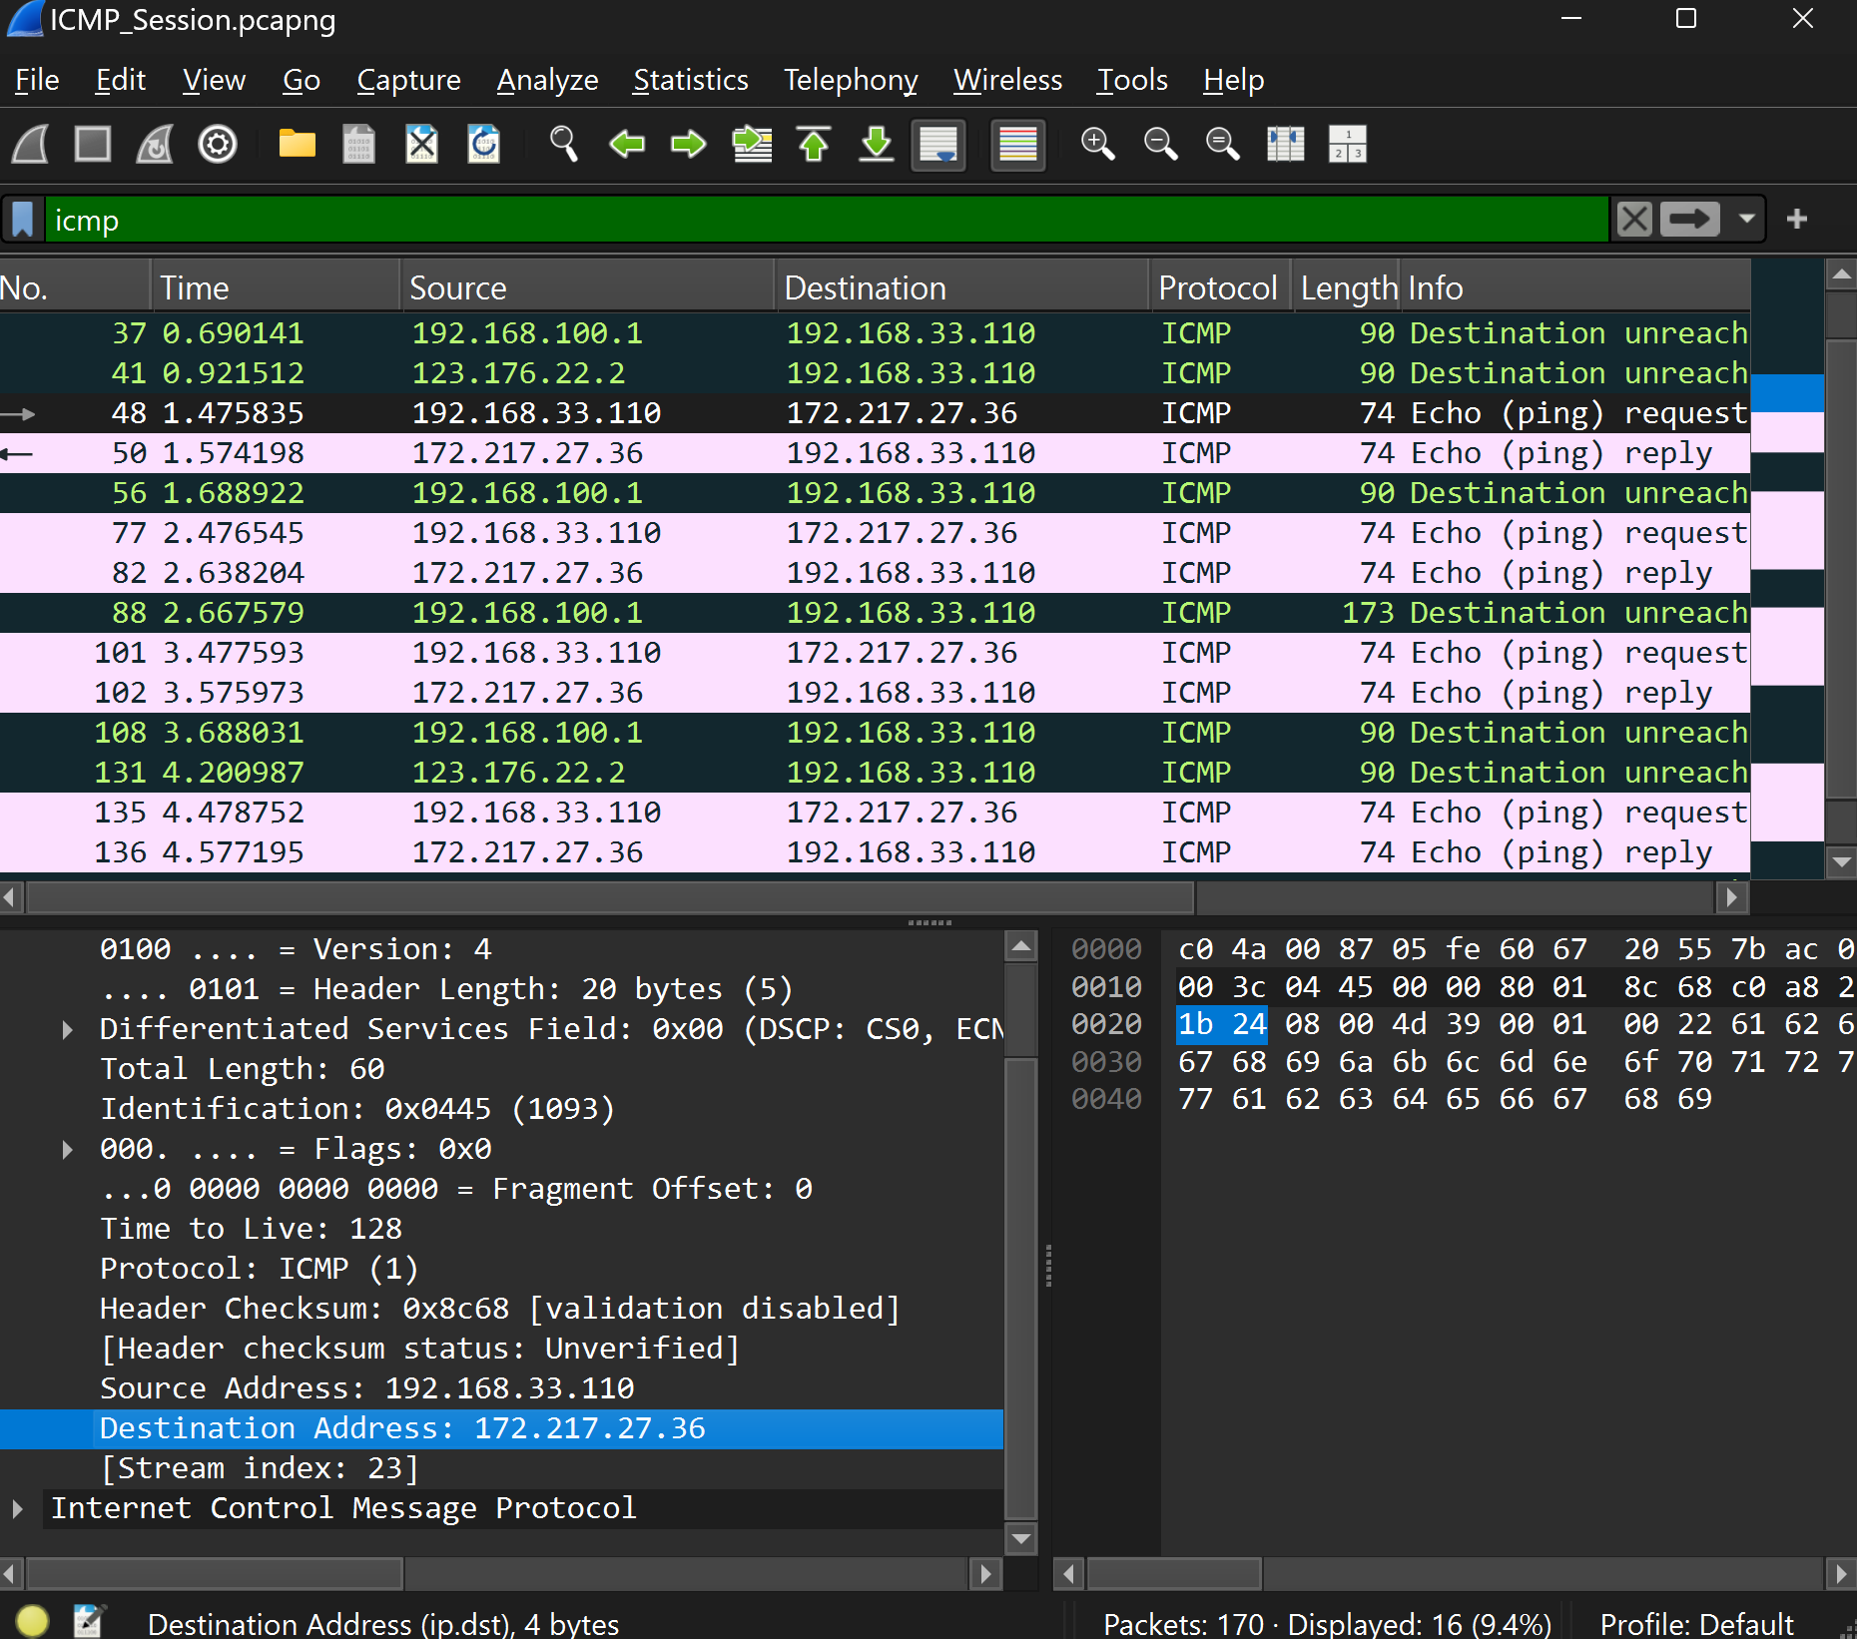

Q6 :

ICMP works at the network layer to help with network issues and error messages.ICMP doesn't need port numbers because it's not meant for application communication.

Q7:

An **ICMP Echo Request** has a **Type** value of **8**, while an **ICMP Echo Reply** has a **Type** value of **0**.

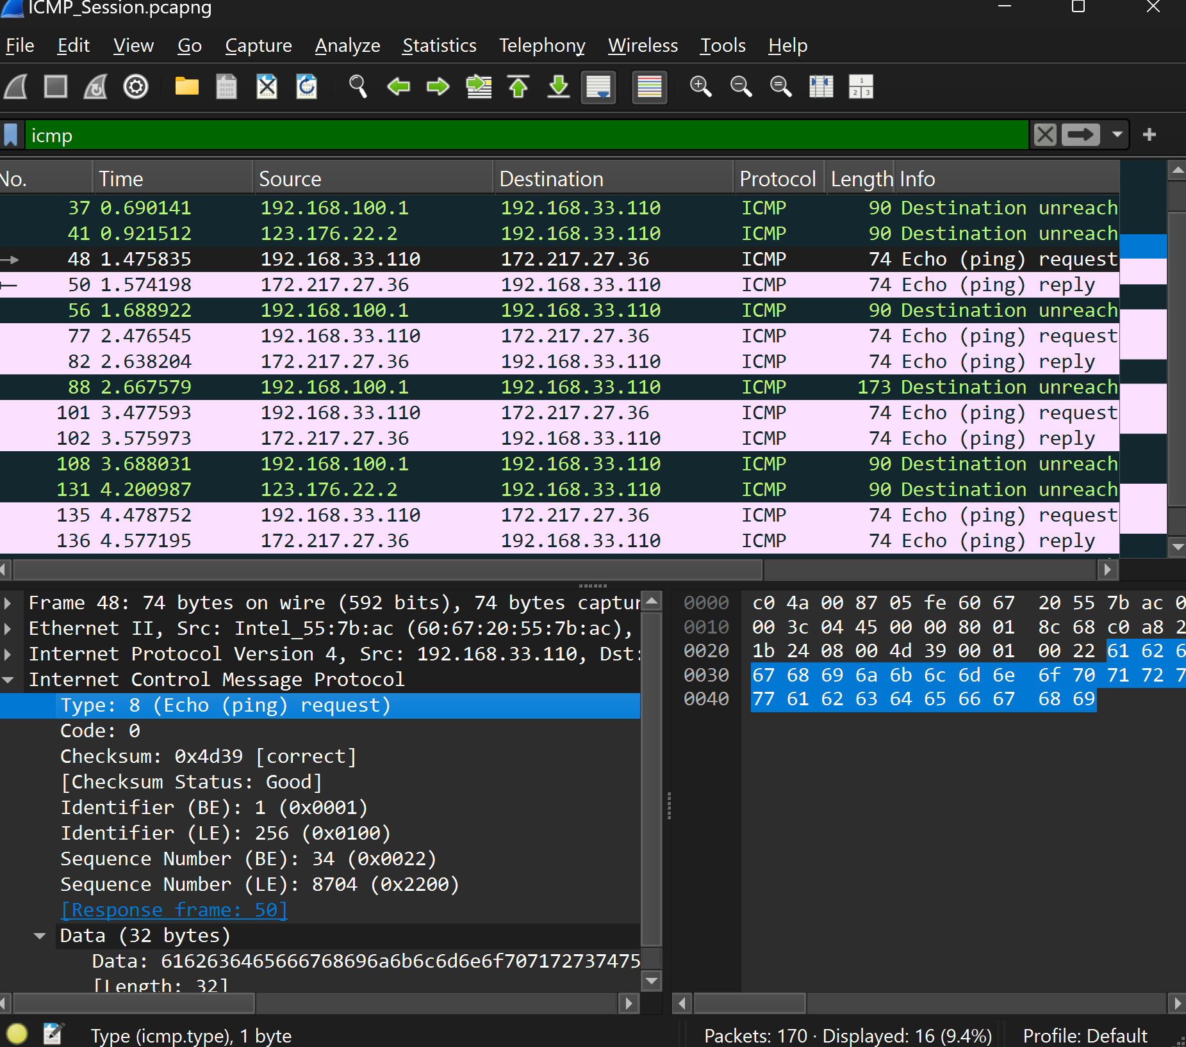

### 8: ICMP Echo Request Packet Details

* **ICMP Type**: **8** (Echo Request)
* **ICMP Code**: **0**

**Additional Fields in the ICMP Packet**

**Checksum**:

* + **Value**: 0x4d38
  + **Status**: Good (indicating no errors)
  + **Size**: **2 bytes**
* **Identifier**:
  + **Big Endian (BE)**: 1 (0x0001)
  + **Little Endian (LE)**: 256 (0x0100)
  + **Size**: **2 bytes**
* **Sequence Number**:
  + **Big Endian (BE)**: 35 (0x0023)
  + **Little Endian (LE)**: 8960 (0x2300)
  + **Size**: **2 bytes**

**Summary of Field Sizes**

* **Checksum Size**: 2 bytes
* **Identifier Size**: 2 bytes
* **Sequence Number Size**: 2 bytes

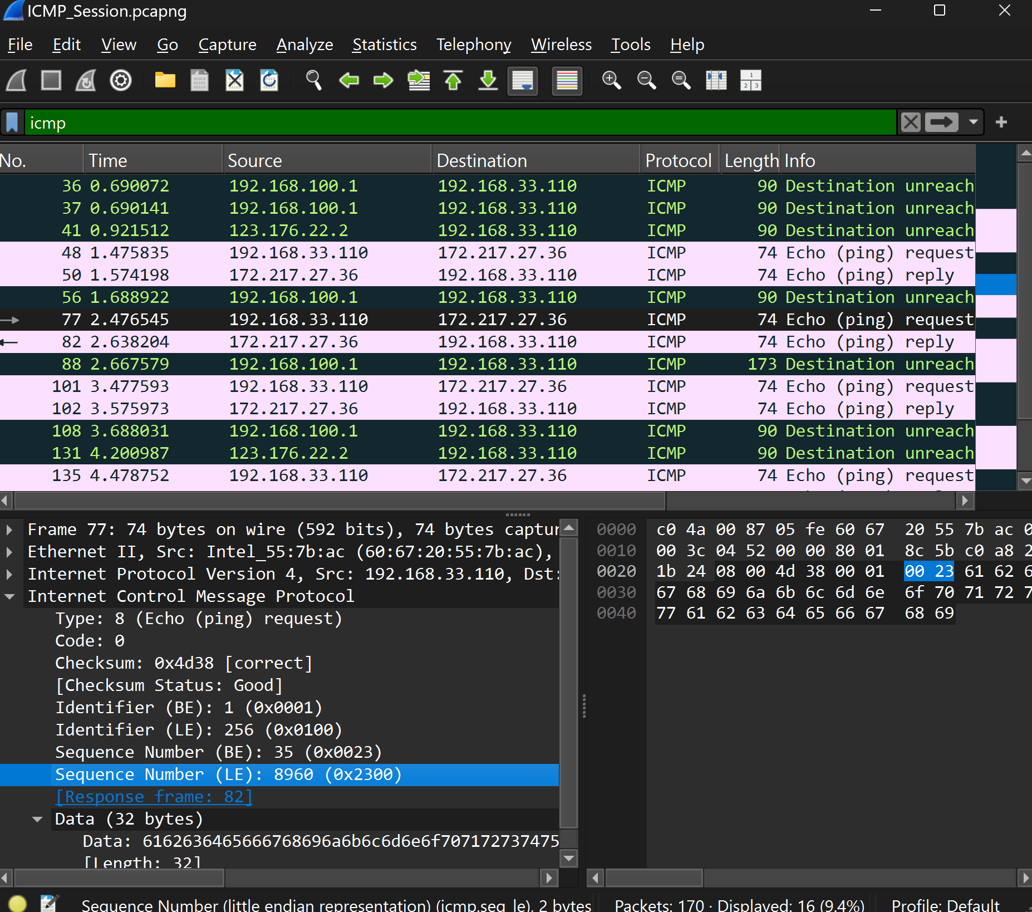

### 9: ICMP Echo Reply Packet Details

* **ICMP Type**: **0** (Echo Reply)
* **ICMP Code**: **0**

### Additional Fields in the ICMP Packet

* **Checksum**:
  + **Value**: 0x5539
  + **Status**: Good (indicating no errors)
  + **Size**: **2 bytes**
* **Identifier**:
  + **Big Endian (BE)**: 1 (0x0001)
  + **Little Endian (LE)**: 256 (0x0100)
  + **Size**: **2 bytes**
* **Sequence Number**:
  + **Big Endian (BE)**: 34 (0x0022)
  + **Little Endian (LE)**: 8704 (0x2200)
  + **Size**: **2 bytes**
* **Response Time**: **98.363 ms**

### Summary of Field Sizes

* **Checksum Size**: **2 bytes**
* **Identifier Size**: **2 bytes**
* **Sequence Number Size**: **2 bytes**

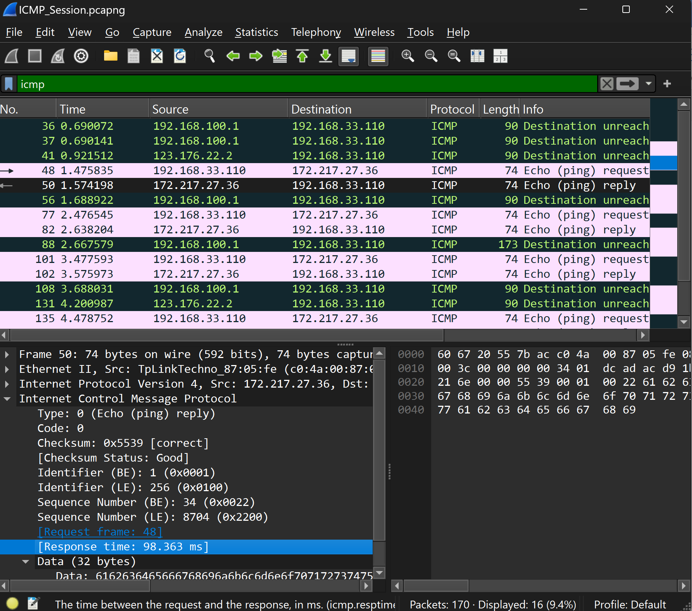

### 10:

### Packet No. 56 ICMP Details

* **ICMP Type**: 3 (Destination Unreachable)
* **ICMP Code**: 3 (Port Unreachable)
* **IP and TCP Headers**: Included to identify the original packet causing the error.
* **Header Depiction**: IP header shows source/destination addresses; TCP header shows segment and ports involved.